Continuous Behavioural Authentication in Financial Technology: Securing Core Banking Dashboards Against Phishing and Session-Hijacking Attacks
[Capstone Project]
Owiro Shawn Ochieng
152066

Supervisor Name
Mr. James Gikera

An Informatics and Computer Science Project Proposal Submitted to the School of Computing and Engineering Sciences in Partial Fulfillment of the Requirements for the Award of a Degree in Bachelor of Science in Informatics and Computer Science

School of Computing and Engineering Sciences
Strathmore University
Nairobi, Kenya

June 2026

Declaration and Approval
We declare that this work has not been previously submitted and approved for the award of a degree by this or any other University. To the best of my knowledge and belief, the research proposal contains no material previously published or written by another person except where due reference is made in the research proposal itself.

Student Name: Shawn owiro

Admission Number: 152066
Student Signature: _________________________ Date: ____12/06/2026_______

The Proposal of Shawn owiro has been reviewed and approved by Mr. James Gikera
Supervisor Signature: _________________________ Date: ________________________

Abstract
Modern digital security is currently facing a crisis due to the total obsolescence of the password, with traditional credentials serving as the primary root cause of most data breaches. While current standards like FIDO2 offer improved "gatekeeper" security, they remain form-centric and fail to address the need for continuous verification in a landscape where identity is constantly under threat. This project proposes NexusID, a continuous adaptive identity system that replaces static login barriers with a passkey-first biometric WebAuthn handshake. To ensure persistent trust throughout a session, the system implements a background machine learning engine that analyzes behavioral signatures such as keystroke dynamics and pointer interaction patterns to generate real-time risk scores. Developed using an Agile Scrum methodology, the architecture utilizes a cloud-native stack comprising TypeScript, Next.js, and NestJS, with PostgreSQL Row-Level Security (RLS) to enforce dynamic, risk-aware access control. Anticipated outcomes include the elimination of phishing vulnerabilities through device-bound cryptography and a significant reduction in session-hijacking risks via sub-100ms behavioral inference at the network edge. By combining identity orchestration with behavioral biometrics, NexusID provides a scalable, zero-trust framework designed to secure both human users and the increasing landscape of AI agents.
Keywords: Behavioral Biometrics, Passkeys, WebAuthn, Identity Orchestration, Machine Learning, Row-Level Security, Zero Trust
Table of Contents
Declaration and Approval ii
Abstract iii
List of Figures vi
List of Abbreviations vii
Chapter 1: Introduction 1
1.1 Background Information 1
1.2 Problem Statement 2
1.3 Objectives 3
1.3.1 General Objective 3
1.3.2 Specific Objectives 3
1.4 Research Questions 4
1.5 Justification 4
1.6 Scope 6
1.7 Limitations and Delimitations 7
Chapter 2: Literature Review 9
Chapter 3: Methodology and System Architecture 16
3.1 Introduction 16
3.2 Research Paradigm 16
3.2.1 Data Acquisition 16
3.2.2 Data Processing and Feature Engineering 17
3.2.3 Model Training and Optimization 17
3.2.4 Model Validation and Testing 18
3.3 System Development Methodology and Justification 18
3.3.1 Justification of Methodology 18
3.4 Methodology Diagram 19
3.4.1 Product Backlog 19
3.4.2 Sprint Planning 19
3.4.3 Sprint Execution 19
3.4.4 Sprint Review and Retrospective 19
3.5 Analysis Diagrams 19
3.5.1 Use Case Diagram 19
3.5.2 Sequence Diagram 20
3.6 Design Diagrams 20
3.6.1 System Architecture 20
3.6.2 Database Schema and RLS Policies 20
3.7 Expected Deliverables 20
3.7.1 Optimized Edge-Native Deep Learning Model 20
3.7.2 Next.js and NestJS Orchestration Platform 21
3.7.3 Database with Native Contextual Enforcements 21
3.8 Tools and Techniques 21
3.8.1 Python and TensorFlow/Keras 21
3.8.2 ONNX (Open Neural Network Exchange) 21
3.8.3 TypeScript, Next.js, and Vercel Edge Runtimes 21
3.8.4 PostgreSQL and Supabase 22
References 23
Appendices 25
Appendix 1: Similarity Report 25
Appendix 2: Gantt Chart 25

List of Figures
Figure 2.1 Conceptual framework 15

List of Abbreviations
MFA – multi-factor authentication
FIDO2 – Fast IDentity Online 2
RATs – Remote Access Trojans
IAM - Identity and Access Management
RLS - Row Level Security
NHIs – Non-Human Identities
AES-256 – Advanced Encryption Standard

Introduction

Background Information
The financial technology (FinTech) ecosystem is undergoing a fundamental transformation in how digital identity is verified and maintained. For decades, access to core banking dashboards and financial administrative interfaces has relied on the old gatekeeper model, where authentication is treated as a one-time, static event occurring exclusively at the perimeter of a session. Traditional knowledge-based authentication relies on credentials, such as passwords, and it has become the primary vulnerability in modern cybersecurity. According to the 2024 Verizon Data Breach Investigations Report (DBIR), compromised credentials remain the number one initial access vector, accounting for 31% of all breaches over the past decade and driving a staggering 77% of basic web application attacks(verizon, 2026). Furthermore, IBM estimates that breaches initiated by stolen credentials cost organizations an average of $4.4 million per incident(Cost of a Data Breach Report 2025 The AI Oversight Gap Think Report, 2025). While financial institutions have adopted MFA and cryptographic, device-bound solutions like FIDO2 to combat initial credential theft, the nature of cyberattacks has evolved.
However, modern financial platforms are no longer exclusively operated by humans, exposing a critical new vulnerability: the rise of "agentic identity" and non-human identities (NHIs), digital credentials used by software, machines, and automated processes to authenticate and access systems. Driven by the rapid integration of generative AI, organisations are deploying autonomous AI agents that independently decide, plan, and execute workflows without asking for human permission(Olden, 2025). In modern enterprise environments, the proportion of NHIs to human users has exploded to an estimated 40:1 ratio(IBM, 2025). While traditional Identity and Access Management (IAM) systems focus on registration-time identity for humans, they severely lack runtime authorisation and governance for AI agents. Ungoverned agentic AI presents a catastrophic risk in banking; an unmonitored AI agent with access to core financial APIs could execute unauthorised autonomous spending or data transfers at machine speed (1Kosmos, 2026).
Attackers are now circumventing the login perimeter entirely by targeting the authenticated state. Through session hijacking, cookie theft, and the deployment of Remote Access Trojans (RATs), adversaries can seize control of active, highly privileged banking sessions. Once inside, traditional Identity and Access Management (IAM) systems are fundamentally blind, lacking the environmental intelligence to distinguish between the legitimate financial operator and an imposter.
To combat this, the field of behavioural biometrics has emerged as a powerful zero-trust mechanism. By analysing the unique "how" of human interaction, such as mouse movement dynamics, path efficiency, and angular velocity entropy, systems can establish a continuous biometric signature of the user (Khan et al., 2024) While behavioral biometrics show promise, current enterprise solutions lack deep integration into core banking network fabrics or native database-layer enforcement, leaving a critical gap in real-time, post-authentication mitigation.
Addressing this gap requires a synthesis of edge-based machine learning and database-level access control. This project proposes NexusID, a passkey-first continuous behavioural authentication system engineered specifically for financial technology environments. By continuously generating dynamic risk scores based on operator telemetry, i.e., mouse movements, keyboard stroke dynamics, and integrating these directly into database architectures via PostgreSQL Row-Level Security (RLS), financial institutions can achieve dynamic role management. This approach guarantees that high-value transactions and sensitive data queries remain protected from post-authentication hijacking, completely invisible to the legitimate operator yet resilient to modern threat vectors.

Problem Statement
Financial institutions rely on core banking dashboards to manage high-value transactions, sensitive customer data, and institutional assets. Ideally, the identity and authorisation of the operator, whether a human employee or an integrated AI agent, should be continuously guaranteed with absolute certainty throughout the entire lifecycle of an administrative session. Access should be inherently risk-aware, seamlessly verifying human operators through natural interaction and maintaining strict runtime boundaries for autonomous agents, ensuring a secure and frictionless zero-trust environment (Eric Olden, 2026; Strata, 2025).
However, modern financial authentication models remain fundamentally perimeter-bound, treating security as a one-time gatekeeping event. While banks heavily invest in multi-factor authentication (MFA) and passwordless logins, these defences offer zero protection in post-authentication; once a session token is generated, the connection is implicitly trusted. Cybercriminals actively exploit this blind spot by utilising malicious keyloggers, cookie theft, and Remote Access Trojans (RATs) to hijack active sessions, bypassing the login screen entirely. Because traditional systems lack continuous environmental validation, a hijacked session appears indistinguishable from a legitimate banking operator. Furthermore, the rapid adoption of agentic AI has introduced a critical governance gap; non-human identities (NHIs) now outnumber human users by an estimated 40:1 ratio, yet traditional IAM platforms lack the runtime authorisation required to govern their autonomous actions. The financial impact of these post-authentication vulnerabilities is catastrophic, driving the financial sector to suffer the highest average data breach penalties globally in 2025 (Cost of a Data Breach Report 2025 The AI Oversight Gap Think Report, 2025; verizon, 2025)
Without continuous, post-authentication verification, financial institutions remain exposed to prolonged attacker dwell times and unauthorised, high-speed asset transfers executed from "trusted" sessions. This study will develop a continuous behavioural authentication and identity orchestration system tailored specifically for financial technology infrastructure. By fusing multi-modal telemetry (mouse and keystroke dynamics) to neutralise human impersonation and integrating edge-computed risk scores directly into PostgreSQL Row-Level Security (RLS), this research will provide a zero-trust framework capable of dynamically governing both human and agentic identities, effectively neutralising session-hijacking attacks in real time.

Objectives

General Objective
The primary objective of this research is to design, implement, and validate NexusID, a passkey-first continuous adaptive identity and behavioural orchestration system engineered to secure high-value FinTech environments by leveraging edge-computed multimodal behavioural biometrics and native PostgreSQL Row-Level Security (RLS) to mitigate post-authentication session-hijacking and govern agentic AI runtime actions.

Specific Objectives
- To analyze and review the current state of post-authentication security vulnerabilities within core banking dashboards
- To study and benchmark how existing behavioural biometric models and identity orchestration solutions address session hijacking and agentic identity governance.
- To review the technical challenges and performance bottlenecks associated with deploying real-time behavioural biometric models in low-latency environments.
- To design and develop the NexusID continuous biometric authentication and orchestration system.
- To test, evaluate, and validate the security efficacy and system performance of the NexusID framework.

Research Questions
- What are the primary post-authentication vulnerabilities within core banking dashboards, and how do modern attack vectors exploit session states after perimeter-bound validation?
- How do existing standalone enterprise behavioral biometric platforms and identity orchestration fabrics evaluate human motor telemetry and govern non-human autonomous identities?
- What technical challenges, computational bottlenecks, and latency limitations hinder the real-time deployment and execution of machine learning models in edge runtime environments?
- How can an end-to-end continuous behavioral authentication architecture be engineered to passively capture typing rhythms and pointer dynamics while implementing runtime data constraints?
- To what degree does the implemented framework effectively distinguish legitimate banking operators from session hijackers, malicious scripts, and rogue agents under variable performance and accuracy constraints?

Justification
Securing core banking administrative interfaces is a paramount priority for the global financial sector due to the sheer volume of liquidity and sensitive customer data governed by these portals. Despite deep investments in perimeter-bound security models, traditional mechanisms fall short because they create a persistent authentication state that remains completely unverified after initial entry.
By shifting the authentication paradigm away from single-point perimeter checks, the framework unifies multimodal behavioral biometrics to create an invisible, continuous identity verification layer. While conventional solutions rely heavily on isolated physiological traits or entry-point validation, this architecture captures ongoing human interaction telemetry by pairing keystroke cadence (inter-key flight and dwell times) with granular mouse interaction dynamics (path trajectories, directional efficiency, and angular velocity). This continuous data fusion operates transparently in the background, preserving interface ergonomics while maintaining strict financial oversight (V et al., n.d.)
Beyond human continuous validation, the technical scope extends directly into the governance of non-human entities by managing agentic identity risks. As modern banking infrastructures increasingly transition toward automated workflows, autonomous AI agents operate inside administrative dashboards at a massive scale, outnumbering human employee profiles (IBM, 2025). Traditional Identity and Access Management (IAM) platforms lack the capability to provide runtime behavioral oversight for these systems. This project establishes standardised operational profiles for valid AI agent execution paths. By mapping these runtime patterns, the architecture introduces a continuous identity orchestration layer capable of applying real-time authorisation to autonomous workloads, preventing machine-speed privilege escalation, token manipulation, or fraudulent asset transfers (Eric Olden, 2026)
To implement this multi-layered security loop without introducing application latency, the architecture eliminates traditional middleware processing bottlenecks through localised edge inference. Centralised cloud-based biometric engines introduce significant latency because large telemetry packages must be continuously funnelled to external servers. This project deploys lightweight machine learning models directly onto stateless V8 edge isolates at the network perimeter. Processing incoming human interaction patterns and machine payloads locally enables sub-100 ms risk scoring, effectively safeguarding the session while fully preserving transaction throughput (vercel, 2026)
The final structural component of this innovation involves anchoring these edge-computed trust metrics directly into the database tier using native PostgreSQL Row-Level Security (RLS) enforcements. Standalone security monitoring systems often suffer from an operational disconnect where real-time threat alerts are decoupled from the underlying data management storage layer, allowing a window of opportunity for data exfiltration before an application can react. By binding edge-computed behavioral threat metrics directly into database-layer RLS policies, the storage engine can dynamically adjust data access filters in real time. If a session score exhibits anomalous variations crossing critical thresholds, the database natively strips access privileges or restricts data queries at the row level, neutralising session-hijacking attempts instantly without necessitating complex and brittle rewrites of the application logic (Dhandala, 2026; makerkit, 2026)

Scope
This study encompasses the architectural design, deployment, and benchmark validation of the NexusID system within a web-based, cloud-native application stack modelled on a financial technology administrative interface. Development is restricted to a unified language ecosystem, utilising TypeScript as the core programming environment. The frontend component is constructed using Next.js to leverage server-side rendering and middle-tier optimisation capabilities, while the backend orchestration layer is engineered using NestJS to handle secure, type-safe API schema processing. Data persistence and security enforcements are handled within a PostgreSQL database infrastructure hosted via Supabase, specifically utilising native Row-Level Security (RLS) enforcements to dynamically handle context-based permissions mapping.
This study isolates explicit telemetry inputs required for continuous verification while strictly adhering to regulatory guidelines such as the General Data Protection Regulation (GDPR)(European Union, 2018). Raw physical biometrics, including facial recognition patterns, retinal details, and physiological characteristics, fall completely outside the boundaries of this research. Instead, data extraction is limited exclusively to non-intrusive human interaction mechanics, which are parsed into anonymised, encrypted vector coordinates via Advanced Encryption Standard (AES-256) at rest. The specific human telemetry attributes gathered include precise inter-key flight timing, typing cadence, and key press dwell metrics, fused alongside mouse movement coordinates, spatial direction variations, path efficiencies, and angular velocity entropy vectors. For the agentic identity framework, data modelling captures runtime call patterns, transaction execution speeds, and API utilisation traces against predefined normal operational bounds.
Functionally, the system is designed to provide automated real-time risk classification, session monitoring, and access mitigation within financial technology portals. The operational boundaries include onboarding sessions through an initial, passkey-first WebAuthn handshake, capturing continuous telemetry batches silently, and executing machine learning inference models at the network perimeter via stateless V8 edge isolates. The model output is explicitly bounded to generate an instantaneous threat score ranging between 0 and 100. This numerical indicator is consumed by PostgreSQL database hooks to automatically filter, restrict, or entirely drop table row queries on active transaction ledgers when scores violate specific security envelopes. Crucially, the functional scope is restricted to detecting, alerting, and filtering read-write access permissions; it does not extend to broader endpoint detection capabilities, network firewalls, hardware virtualisation security, or automated financial compliance auditing.
The chronological and operational timeline of this research covers an iterative four-month developmental roadmap designed under an Agile Scrum framework. The introductory phase focuses on compiling literature reviews, security audits of financial interfaces, and baseline configuration parameters. The mid-market phase isolates model training, client telemetry collection logic, and the deployment of edge isolates using specialised inference scripts. The final phase covers system security validation, during which the platform is subjected to scripted adversarial conditions, including session token theft simulations, keylogging software emulation, and out-of-bounds autonomous agent transactions to generate concrete statistical metrics on operational performance, enforcement latency, and security effectiveness.

Limitations and Delimitations
This study is explicitly delimited to the continuous verification of human and non-human identity contexts exclusively within web-based administrative workflows, specifically simulating core financial technology banking dashboards. It intentionally excludes native desktop operating system tracking, hardware virtualisation perimeters, mobile touchscreen swipe gestures, and endpoint telecommunication routing protocols. By choice, the behavioral biometric framework strictly isolates non-intrusive human interaction features, specifically extracting pointer metrics while completely omitting physical biometrics to ensure absolute compliance with standard European Union General Data Protection Regulation data minimisation models. Furthermore, the operational context of agentic identity governance is delimited to establishing baseline execution curves for automated system hooks and auditing transactional read-write API requests against out-of-bounds behaviour. It does not attempt to construct wide-spectrum runtime mitigation paths for third-party security orchestration engines. Finally, database enforcements are explicitly delimited to native PostgreSQL row-level security architectures operated via a centralised cloud instance provider, choosing not to investigate horizontal storage sharding patterns, distributed multi-region replication environments, or alternate NoSQL ledger storage models.
Conversely, several technical and structural limitations constrain the findings and generalisability of this project. A primary technical challenge involves physical user data variations caused by hardware inconsistencies across endpoint collection nodes, as variations in client mouse sampling frequencies, polling rates, and physical membrane keyboard microswitches can introduce hardware-induced anomalies into the input stream. Environmental and human physiological factors represent an unavoidable limitation; sudden shifts in an employee's physical state due to stress, exhaustion, muscle fatigue, or fine motor control injuries could trigger uncharacteristic typing profiles, artificially spiking false rejection rates and causing friction within high-volume financial banking applications. The machine learning architecture relies entirely on batch capture loops, meaning that while the edge runtime processing remains highly optimised under sub-100ms thresholds, a structural initialization lag exists during the first few seconds of user typing, creating a brief window of vulnerability before a robust anomaly detection vector can be computed. Additionally, while the system is highly effective at identifying standard session hijacking, automated scraping bots, and remote access Trojans, it faces distinct validation boundaries when confronted with advanced, low-and-slow human impersonation attacks, where an attacker intentionally trains to mirror a specific operator's spatial movement cadences over prolonged periods. Lastly, because the testing phases rely entirely on simulated adversarial scenarios, penetration testing frameworks, and controlled data loads, the empirical performance metrics gathered throughout this study may experience variations when subjected to unpredictable transaction volumes or un-baselined infrastructure failures within production enterprise banking nodes.

Literature Review
2.1 Introduction
To systematically contextualize the architecture of a continuous adaptive behavioral orchestration model within financial technology platforms, this literature review presents an exhaustive academic investigation into post-authentication vulnerabilities, continuous modal validation frameworks, low-latency execution engines, and data security layer mapping topologies. The structural framework of this review is partitioned into specific thematic groupings that address the research focus directly.
Section 2.2 dissects the granular state of post-authentication vulnerabilities inside core banking platforms, explicitly evaluating the inner dynamics of modern authentication and the tactical progression of session hijacking, token theft, and keylogging implants. Section 2.3 contextualizes related works in the continuous authentication domain, benchmarking existing market platforms to establish feature extraction limits and performance parameters for human motor telemetry and non-human machine identity oversight. Section 2.4 dissects the technical challenges and performance bottlenecks related to low-latency edge execution models, identifying critical gaps in current architectures. Finally, Section 2.5 details the conceptual framework and architectural integration of edge computing engines with native database-layer access filters, illustrating how contextual risk vectors can be natively enforced without modifying higher-level application code architectures.
2.2 Current State of Post-Authentication Security and Inner Dynamics
2.2.1 The Inner Dynamics of Traditional Authentication
The security architecture of conventional web-based financial dashboards relies heavily on a static "gatekeeper" model. Upon the successful completion of an initial multi-factor authentication (MFA) protocol or a passkey-first cryptographic handshake, the identity of the operator is treated as an immutable parameter for the duration of the session. The inner workings of this state management relies on the generation of an active session token or JSON Web Token (JWT) stored in client-side cookie containers. These tokens are appended to all subsequent network requests to verify page permissions without retriggering access gates (Pusara & Pusara, 2007).

However, because the initial perimeter has been heavily fortified by passwordless technologies, cybercriminals have adapted by focusing exploitation efforts downstream from entry interfaces. Attackers frequently deploy malicious software or Remote Access Trojans (RATs) to capture active, trusted sessions via browser cookie exfiltration. Once stolen, an attacker injects the cookie into an external browser, bypassing upstream MFA checkpoints entirely. Furthermore, while passwordless frameworks mitigate static secret exposure, corporate operations require manual inputs such as structural ledger queries. Malicious keyloggers exploit this by capturing exactly what is typed on the local hardware bus before network encryption takes place, rendering traditional perimeter defenses blind to the compromise. Compounding these human-centric vulnerabilities is the rapid integration of Agentic Artificial Intelligence. In modern enterprise environments, autonomous non-human identities (NHIs) outnumber human operators by an estimated 40:1 to 80:1 ratio, yet traditional systems lack the runtime behavioral oversight required to govern these machine identities post-deployment (Eric Olden, 2026; IBM, 2025)
2.2.2 Key Post-Authentication Vulnerabilities
Because the perimeter has been heavily fortified by passwordless technologies like(FIDO Alliance, 2026) , cybercriminals have adapted by focusing exploitation efforts downstream from entry interfaces. Existing models face critical vulnerabilities:
Session Hijacking and Token Theft: Attackers deploy malicious software or Remote Access Trojans (RATs) to capture active, trusted sessions via browser cookie exfiltration. Once stolen, an attacker injects the cookie into an external browser, bypassing upstream MFA checkpoints entirely (Verizon, 2025; verizon, 2026) Traditional identity tools cannot differentiate between a legitimate employee querying a ledger and an imposter replaying an authenticated cookie.
Malicious Keylogging Implants: While passwordless frameworks mitigate static secret exposure, financial operations require manual inputs such as structural ledger queries and asset transfer approvals. Keyloggers capture exactly what is typed on the local hardware bus before network encryption takes place, rendering traditional perimeter defenses blind to the compromise (The Federal Reserve, 2026)
The Agentic AI Blind Spot: The financial sector is rapidly transitioning toward automated workflows where autonomous AI agents interact directly with core banking APIs. Currently, non-human identities (NHIs) outnumber human operators by an estimated 80:1 ratio across enterprise cloud environments, yet traditional Identity and Access Management (IAM) platforms lack the runtime behavioral oversight required to govern them post-deployment (Eric Olden, 2026).
2.3 Related Works in Continuous Authentication
To address these vulnerabilities, several enterprise behavioral biometrics and identity orchestration frameworks have been developed. This section benchmarks existing continuous authentication platforms, analyzing their inner workings and underlying machine learning models.
2.3.1 BioCatch Connect
BioCatch Connect is a premier behavioral analytics platform designed for high-resource financial institutions. The system continuously analyzes over 17 billion user sessions per month, collecting more than 3,000 anonymized data points per session including keystroke activity, mouse dynamics, and device handling features. The inner workings rely on Neural Network Anomaly Detection models that parse data through preprocessing layers to establish normative user profiles (BioCatch, 2025; Sharell Barshishat, 2026)
While highly accurate at predicting social engineering and mule account activity, BioCatch functions as a specialized, high-cost cloud ecosystem. Its risk assessments are processed centrally and managed via external API gateways, which introduces network latency and prevents instantaneous database-tier remediation during active data exfiltration events.
2.3.2 1Kosmos BlockID
1Kosmos BlockID provides an authentication framework that integrates passwordless FIDO2 passkeys with continuous user verification tools. Utilizing a decentralized identity approach with zero centralized PII storage, the platform boasts a 99.6% Target Accept Rate (TAR) and a mathematically rigid 0.01% False Accept Rate (FAR) during initial identity proofing (Nick Roquefort-Villeneuve, 2020)
The continuous tracking loop within 1Kosmos is largely device-bound, leaning heavily on operating system hardware permissions and initial biometric unlocks (e.g., facial or fingerprint scans). It focuses primarily on authentication onboarding rather than deep, continuous human motor telemetry tracking, and it completely lacks visibility into the runtime behaviors of autonomous AI agents.

2.3.3 BehavioSec Platform (LexisNexis)
Fitted within broader enterprise identity networks, BehavioSec captures granular keyboard and mouse interaction dynamics to calculate real-time user trust baselines. The platform extracts high-fidelity features such as key press dwell time, inter-key flight time, and pointer velocity entropy to generate a continuous "Behavioral Score." Its machine learning framework dynamically flags distinct anomalies, utilizing logical Boolean flags such as Bot Detection (identifying excessively uniform rhythms) and Replay Attack markers (LexisNexis, 2026)
BehavioSec operates effectively as an analytical engine but is dependent on external middleware suites (e.g., Threat Metrix) for access orchestration. It lacks independent edge-native execution scripts, forcing organizations to build custom application-layer integrations to handle policy enforcements, significantly increasing architectural overhead.
2.3.4 Strata Maverics Fabric
Strata Maverics is an identity orchestration framework built to manage multi-cloud identity sprawl. Recognizing that AI agents operate dynamically and ephemerally, Strata introduces architectural patterns to govern agentic identities through "Just-in-Time" (JIT) provisioning and OAuth orchestration (Strata Identity, 2026).
While Strata sets the standard for managing machine identity policies and cross-domain trust chains, it operates at the token and API gateway level. The system lacks the low-level behavioral analytics engines required to monitor human neuromuscular movement patterns or detect real-time keylogger compromises on an active human session.
2.4 Gaps in Related Works
A critical synthesis of the reviewed platforms reveals four persistent structural limitations within the current continuous authentication landscape that this study explicitly targets:
Most implementations uncouple threat scoring from data-tier management. As seen in Table 2.1 Comparative Analysis of Reviewed Systems, systems like BioCatch and BehavioSec generate risk scores within external application modules. This creates an asynchronous processing delay that allows malicious scripts or hijacked tokens to execute queries on the database before permissions filters can update and sever access (supabase, 2026)
Existing behavioral biometric platforms rely heavily on centralized cloud processing. Piping raw continuous telemetry data (e.g., thousands of mouse coordinate variations per second) to remote servers introduces high processing overhead and bandwidth costs . Current standalone platforms fail to achieve sub-100ms risk scoring boundaries because they rely on remote backend models rather than localized edge execution.
Current solutions operate in silos. Platforms that excel at human telemetry (BehavioSec) fail to monitor non-human autonomous scripts, while platforms managing NHIs (Strata, 2025) lack human physical tracking capabilities. With agentic AI operating at machine speed and forming complex delegation chains, unified runtime authorization that monitors both human micro-movements and machine API cadences is completely absent in the market (IBM, 2025)
Tracking raw micro-movements and typing logs poses massive data compliance risks under privacy frameworks. Existing systems often struggle to balance high-fidelity feature engineering with privacy preservation, lacking an architecture that quantizes models and processes data statelessly at the network edge to avoid the long-term retention of raw physical identifiers.
Table 2.1 Comparative Analysis of Reviewed Systems
System | ML Model & Core Focus | Statistical Benchmark | Critical Gaps | Database Enforcement
BioCatch | Neural Networks; Anomaly Detection | 17 Billion Sessions/Month; 3000+ Signals | Cloud latency dependencies; high enterprise costs. | Application Middleware
1Kosmos | Biometric Match; Decentralized Ledger | 99.6% TAR; 0.01% FAR | Device-bound constraints; no NHI runtime models. | Identity Provider Gateway
BehavioSec | Time-Series Kinematics; Vector Mapping | Sub-second anomaly flagging (Bot/Replay) | Complex integration; lacks native data-layer hooks. | Application Middleware
Strata | OAuth Orchestration; JIT Provisioning | Designed for 80:1 Machine-to-Human ratio | Lacks human behavioral (motor telemetry) tracking. | Network Perimeter

2.5 Conceptual Framework
Definition and Purpose
The conceptual framework for this study theoretically and structurally outlines the development of NexusID, demonstrating how generative edge AI and behavioral biometrics can be optimized to address the latency, enforcement, and dual-identity governance gaps identified in the literature.
The framework is driven by distinct input variables divided by identity type. For human operators, the system silently captures organic neuromuscular telemetry, specifically tracking key press dwell time, inter-key flight time , cursor path efficiency, and angular velocity entropy (Khan et al., 2023). For autonomous AI agents, the inputs consist of programmatic runtime data, including API request frequency, execution intervals, and data payload structures.
These inputs flow into the processing tier, which abandons traditional cloud models in favor of edge inference. The processing architecture utilizes high-speed, stateless V8 edge isolates. Within these edge nodes, deep learning anomaly detectors (such as lightweight LSTMs) serialized into optimized ONNX formats execute instantly. The model analyzes the incoming input vectors statelessly against an encrypted, quantized "Golden Baseline" previously established for the specific user or agent account.
The output variables of this process are twofold. First, the edge model generates a dynamic, probabilistic risk score ranging from 0 to 100. Rather than sending this score to application middleware, the framework enforces database mitigation. The risk score is securely packaged into a JSON Web Token (JWT) and intercepted directly by PostgreSQL Row-Level Security (RLS) policies. If the probability score crosses a designated threat threshold (e.g., indicating a robotic cursor trajectory within an authenticated session), the database automatically masks sensitive columns, disables write-access, or completely drops row visibility. This ensures that attacks are neutralized at the lowest possible infrastructure level in real-time, achieving true continuous zero-trust without requiring complex application-layer modifications.
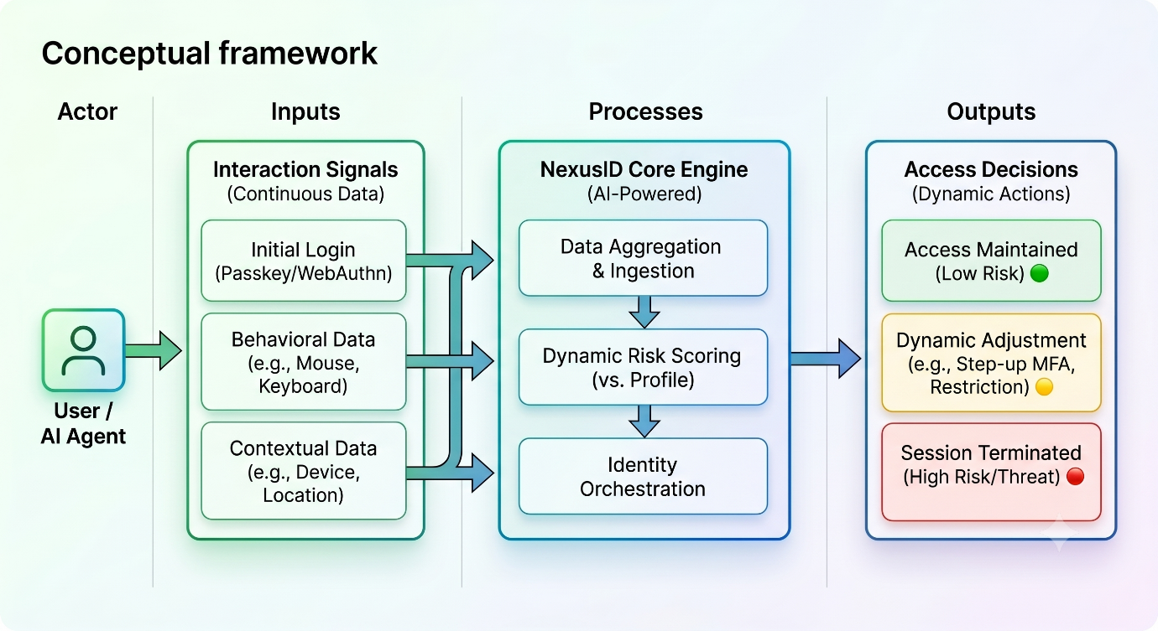
Figure 2.1 Conceptual framework

Methodology and System Architecture

Introduction
This chapter introduces the methodology used to develop the NexusID Continuous Adaptive Identity and Behavioral Orchestration System, providing a clear overview of its structure and key technical components. The project followed an Object-Oriented Analysis and Design (OOAD) approach, which supported a modular and iterative development process for integrating complex machine learning pipelines with cloud-native web architectures. The chapter presents the experimental design used for training and validating the behavioral anomaly detection models, followed by the development approach for the edge-inference engine and its supporting database enforcement system. It also outlines the system analysis and design diagrams, expected deliverables, and the specific technological stack applied throughout the development of the system.

Research Paradigm
This project adopted an experimental research paradigm, where the effectiveness of the behavioral biometric models and the edge orchestration framework was validated through systematic data preparation, model training, and performance evaluation under simulated adversarial conditions. The primary objective was to build a reliable, zero-trust system capable of accurately detecting post-authentication session hijacking and rogue AI agent activity without introducing noticeable application latency.
This experimental approach involved setting clear and measurable objectives, such as minimizing the False Acceptance Rate (FAR) of imposters, maintaining a low False Rejection Rate (FRR) for legitimate operators, and ensuring end-to-end inference latency remained below the 100ms threshold required for real-time edge computing. The process included collecting and preprocessing multimodal interaction telemetry (mouse kinematics and keystroke dynamics), applying mathematical vector mapping techniques to normalize the input data. Deep learning models, specifically Long Short-Term Memory (LSTM) networks, were then trained and evaluated. This empirical approach ensured that the architecture’s performance could be tested, refined, and validated under controlled conditions to achieve dependable security enforcements.

Data Acquisition
This phase involved collecting and preparing the foundational datasets required for training and evaluating the behavioral AI models. For this project, raw mouse dynamics and keystroke telemetry data were sourced from academic repositories such as the Balabit dataset and Kaggle collections specifically curated for continuous user authentication tasks (Khan et al., 2023). These datasets provided structured logs of user interactions, including timestamps, X/Y screen coordinates, and key press events, which were essential for building a robust baseline. To simulate the specific constraints of financial technology dashboards, additional interaction arrays were recorded manually to represent the programmatic API call cadences of autonomous AI agents.

Data Processing and Feature Engineering
Before the machine learning engine could evaluate an identity, raw physical inputs had to be mathematically mapped into high-fidelity signal vectors. This phase transformed raw time-series event logs into a standardized format suitable for deep learning. The system focused on extracting the subconscious "physics of behavior":
Keystroke Dynamics Extraction The algorithm converted timing intervals into distinct features using the press timestamp and release timestamp for sequential key actions. The engineered features included Dwell Time, calculating the duration a specific key was held down and Flight Time, measuring the speed of transitions between consecutive keys.
Pointer Dynamics Extraction Raw mouse coordinate events were translated into complex spatial vectors. The processing layer calculated Path Efficiency (the ratio of ideal Euclidean distance to actual path distance), Jerk Standard Deviation (the third derivative of position over time to measure motor smoothness), and Angular Velocity Entropy (to measure randomness in direction changes) (Pusara & Pusara, 2007)
These feature arrays were normalized to ensure input uniformity. To expand the dataset artificially and boost model generalization against varying hardware sampling rates, synthetic jitter and minor temporal augmentations were applied to the training vectors.

Model Training and Optimization
This project employed deep learning architectures, specifically Long Short-Term Memory (LSTM) networks, to analyze and classify the sequential, time-series nature of the behavioral vectors. The dataset was separated into distinct training and validation groups (an 80/20 split) to carefully evaluate model performance and prevent overfitting. The LSTM architecture was selected due to its superior ability to retain the contextual "memory" of long sequences of user interactions, allowing it to differentiate between the natural, flowing cadence of a human and the disjointed execution of a scripted bot.
Crucially, because NexusID requires real-time execution at the network edge, the models underwent extensive optimization post-training. The models were serialized into the Open Neural Network Exchange (ONNX) format and subjected to 8-bit integer quantization. This quantization process compressed the mathematical weights, dramatically shrinking the binary footprint to conform to the strict 128MB memory constraints of V8 edge isolates without sacrificing significant classification accuracy.

Model Validation and Testing
The trained and quantized models were rigorously assessed through comprehensive testing procedures. An independent test dataset, deliberately excluded from the training phase, served for ultimate evaluation to objectively determine the model's ability to identify previously unseen impersonation attempts. Performance was tested using metrics such as accuracy, precision, recall, and F1-score for imposter detection. Furthermore, latency benchmarks were strictly monitored to ensure the end-to-end execution of the serialized ONNX model inside the Vercel Edge Runtime remained within the acceptable sub-100ms operational envelope.

System Development Methodology and Justification
This project used an Agile methodology, specifically the Scrum framework, to guide the development of the continuous behavioral orchestration system. Development was organized into iterative, two-week sprints, with each sprint focusing on distinct architectural layers: client-side telemetry collection, edge model optimization, and backend database security integration. Although the project was undertaken individually, Scrum practices such as sprint planning, progress tracking, and iterative reviews were followed to maintain structure and support continuous refinement.

Justification of Methodology
The development of an AI-based behavioral orchestration system required continuous testing, mathematical refinement, and seamless integration between frontend client states and backend database rules. Using the Agile methodology was well-suited to this project because it supported flexible development. Agile practices are exceptionally effective in machine learning projects, as they allow for rapid adjustments during model training and immediate testing of edge deployment constraints. Given that this project involved quantizing complex LSTM networks and integrating them into native PostgreSQL Row-Level Security (RLS) policies, Scrum provided the necessary structure for isolating failures and adapting to integration challenges.

Methodology Diagram

Product Backlog
This served as the master list of all features and architectural tasks needed for the project. For NexusID, the backlog included tasks such as creating the silent JavaScript event listeners, mathematically mapping the Dwell/Flight time algorithms, training the LSTM baseline models, configuring the Vercel Edge Functions, and writing the PostgreSQL RLS SQL policies.

Sprint Planning
Before starting work, the specific tasks to be completed during the upcoming sprint were selected from the product backlog. For example, Sprint 1 focused exclusively on data acquisition and Python-based feature extraction, while Sprint 3 focused entirely on Edge function deployment and JSON Web Token (JWT) signing.

Sprint Execution
This was the defined period during which the selected tasks were engineered. Each sprint resulted in a working piece of the system architecture, such as a successfully compiled ONNX model binary or a functional Next.js client interface.

Sprint Review and Retrospective
At the end of each sprint, the completed module was reviewed against the performance requirements (e.g., verifying the edge inference executed in under 100ms). The process was then reviewed to identify optimization strategies for the subsequent sprint, ensuring continuous architectural refinement.

Analysis Diagrams
Analysis diagrams are visual tools used during the system design phase to help understand, document, and map how the complex continuous authentication architecture behaves and communicates.

Use Case Diagram
This diagram identified the main actors of the system the Human Operator, the Autonomous AI Agent, and the Malicious Threat Actor and their interactions with the system boundaries. It outlined activities such as navigating the financial dashboard, the background capture of telemetry, and the automated restriction of data access upon threat detection.

Sequence Diagram
The sequence diagram visually represented the real-time operational loop of the NexusID system. It illustrated the precise chronological steps:
- The operator interacts with the browser (Next.js).
- The client silently batches 60Hz telemetry vectors and sends an API request.
- The Edge Function (Vercel) intercepts the request, retrieves the user's Golden Baseline, and runs the ONNX inference model statelessly.
- The Edge Function injects the resulting Risk Score into a JWT and forwards the request to the database.
- PostgreSQL reads the JWT, applies RLS filtering, and returns the strictly authorized data payload.

Design Diagrams

System Architecture
The architecture diagram outlined the complete, distributed framework. It demonstrated how the cloud-native frontend (Next.js) interfaced with the stateless middleware (Vercel Edge Runtimes) to execute the machine learning model. It explicitly mapped the secure transition of the behavioral threat score across the network boundary to the backend storage layer (Supabase PostgreSQL), highlighting the zero-trust separation of concerns.

Database Schema and RLS Policies
This defined the structure of the system's relational data using PostgreSQL. Rather than just mapping traditional tables (e.g., Users, Financial Ledgers), the design explicitly documented the native Row-Level Security SQL configurations. This included defining the dynamic functions used to parse the behavioral risk score out of the JWT claims and the subsequent policy logic used to filter or drop ledger rows if the score exceeded predefined safety thresholds.

Expected Deliverables

Optimized Edge-Native Deep Learning Model
A core deliverable is the trained, serialized, and quantized LSTM deep learning model capable of identifying behavioral anomalies based on physical telemetry vectors. The model is highly optimized to run statelessly within the 128MB constraints of a V8 edge isolate, ensuring real-time execution capabilities.

Next.js and NestJS Orchestration Platform
The functional software deliverable is a full-stack web application simulating a high-value financial dashboard. The frontend (Next.js) includes the silent, non-intrusive event listeners for capturing continuous mouse and keyboard dynamics. The backend API routing utilizes NestJS to handle type-safe data transfers and JWT orchestration between the edge nodes and the database.

Database with Native Contextual Enforcements
A configured PostgreSQL database (hosted via Supabase) that implements custom Row-Level Security policies. This deliverable proves the system's ability to natively restrict, mask, or drop data queries based on the edge-computed behavioral trust score, neutralizing session hijacking attempts without relying on application-layer logic.

Tools and Techniques

Python and TensorFlow/Keras
The artificial intelligence and initial data modeling components were developed using Python. The deep learning Long Short-Term Memory (LSTM) networks were built and trained offline using the TensorFlow and Keras frameworks. Python was also utilized for the complex mathematical feature engineering required to extract path efficiency and angular velocity entropy from raw datasets.

ONNX (Open Neural Network Exchange)
To bridge the gap between heavy Python training environments and lightweight web deployments, the ONNX framework was utilized. ONNX allowed the trained TensorFlow models to be serialized, quantized (compressed), and exported into a format readable by JavaScript-based web runtimes.

TypeScript, Next.js, and Vercel Edge Runtimes
The core application and orchestration layers were engineered entirely in TypeScript to ensure strict type safety. Next.js was utilized for the frontend architecture. Crucially, Vercel Edge Runtimes (stateless V8 isolates) were employed as the deployment technique for the middleware inference engine, allowing the machine learning model to execute securely at the network perimeter with sub-100ms latency.

PostgreSQL and Supabase
PostgreSQL served as the relational database management system. Supabase was utilized as the cloud hosting platform due to its robust, native support for JSON Web Token (JWT) integration and advanced Row-Level Security (RLS) enforcement. This technology was critical for demonstrating the direct mapping of behavioral risk scores to actual data access restrictions.

System Analysis and Design

Introduction
This chapter presents the analysis and design of the NexusID Continuous Adaptive Identity and Behavioral Orchestration System. It defines the specific requirements the system must satisfy, the data and interfaces it depends on, and the Object-Oriented Analysis and Design (OOAD) diagrams used to communicate the system's structure and behavior. The Unified Modeling Language (UML) diagrams presented in the following sections serve to bridge the gap between the theoretical machine learning models and the practical cloud-native deployment, providing a clear blueprint for the implementation of the zero-trust framework.

System Requirements
The system requirements define the specific capabilities, performance constraints, and data-handling rules that the complete NexusID architecture must satisfy. These requirements are directly traceable to the research objectives and are engineered to mitigate post-authentication session hijacking.

Functional Requirements
Functional requirements define the core behaviors and tasks the system must execute to provide continuous security.
- The system shall allow an authorized administrator to seamlessly capture a minimum threshold of keystroke and mouse telemetry to establish a "Golden Baseline" profile upon initial onboarding.
- The client-side application shall silently capture and batch user interaction telemetry (key-down, key-up, and cursor coordinates) at a steady 60Hz frequency without blocking the main browser thread.
- The edge inference engine shall ingest incoming telemetry batches, compare them against the established baseline, and generate a dynamic risk score (0–100) indicating the likelihood of session compromise.
- The database layer shall natively intercept the edge-computed risk score via a JSON Web Token (JWT) and execute Row-Level Security (RLS) policies to automatically restrict read/write access if the risk score exceeds defined thresholds.

Non-Functional Requirements
Non-functional requirements describe the quality characteristics, performance bounds, and security constraints under which the NexusID system must operate.
- Performance: The edge-based machine learning inference loop shall complete execution and return a risk score in under 100 milliseconds to preserve seamless transactional throughput.
- Efficiency: The serialized Deep Learning anomaly detection model (ONNX format) must remain under a strict 128MB memory ceiling to successfully execute within a stateless V8 edge isolate environment.
- Security & Privacy: Raw textual inputs or exact characters typed by the user shall never be transmitted or stored. All extracted neuromuscular features shall be mathematically anonymized and encrypted at rest using AES-256.
- Reliability: The system shall maintain a False Rejection Rate (FRR) of less than 3% during continuous session validation to prevent unnecessary lockouts for legitimate operators.

Data Requirements
Data requirements dictate the structure and lifecycle of the information the system ingests and protects.
- The system requires numeric arrays representing spatial ($X,Y$) coordinates and temporal ($T$) timestamps to derive metrics such as Euclidean path efficiency and angular velocity entropy.
- Raw input telemetry batches must remain highly temporary and be permanently purged from the edge runtime memory immediately after the inference execution is complete.

Interface and Integration Requirements
These requirements describe how the system interacts with external frameworks and software components.
- The system must interface seamlessly with standard identity providers (e.g., FIDO2 passkeys) during the initial login phase before initiating continuous session protection.
- The system requires a PostgreSQL-compliant connection protocol to successfully transmit signed JWT context claims containing the behavioral risk score to the Supabase backend.

System Analysis Diagrams
This section presents the UML diagrams used to analyze the problem domain, map external actors, and define the boundaries and workflows of the system.

Use Case Diagram
The Use Case diagram provides a high-level view of how external actors interact with the core banking interface and how the system continuously monitors those interactions in the background. The primary actors identified are the Legitimate Human Operator, the Autonomous AI Agent, and the Malicious Threat Actor.
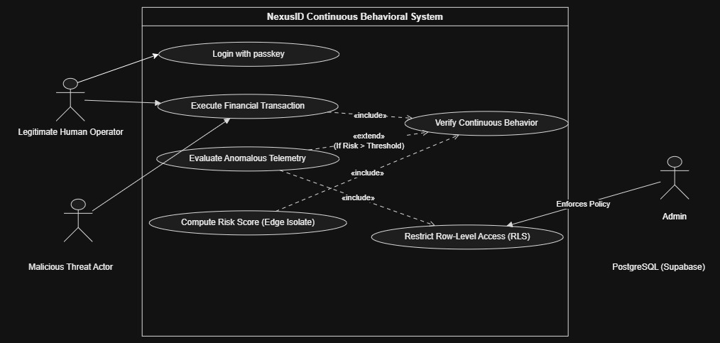
Figure 4.1 Use case Diagram

The diagram illustrates that while all actors attempt to access the "Execute Financial Transaction" use case, their pathways converge at the "Verify Continuous Behavior" inclusion point. A Malicious Threat Actor triggers the "Evaluate Anomalous Telemetry" extension due to a high risk score, which subsequently invokes the "Restrict Row-Level Access" function managed by the Supabase Database.

Activity Diagram
The Activity diagram models the step-by-step workflow of the continuous authentication process, illustrating the parallel processing of telemetry and the conditional access decisions.
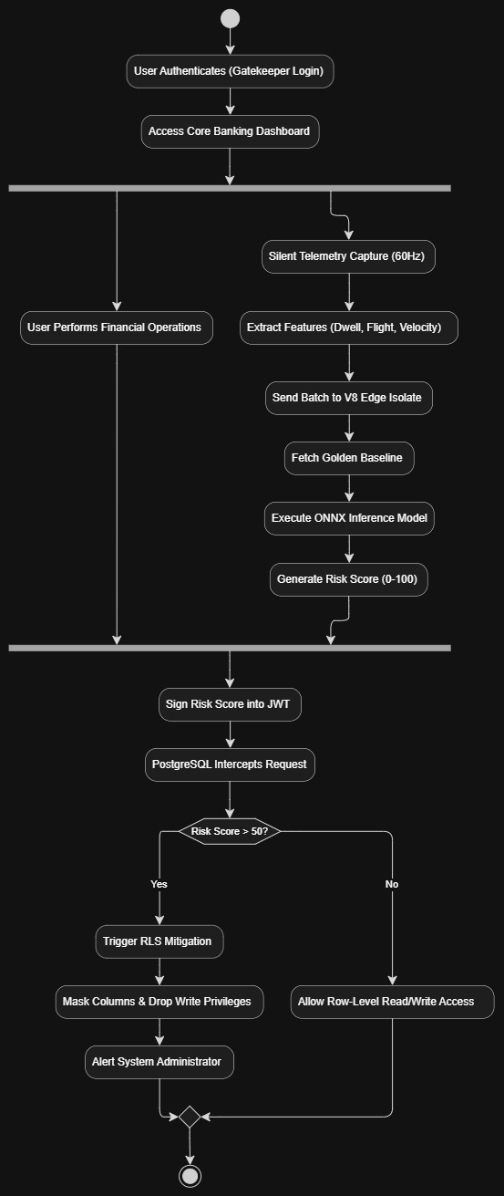
Figure 4.2 Activity Diagram

This workflow highlights the parallel nature of the system. While the user interacts normally with the dashboard, the telemetry capture and edge inference run asynchronously. The critical decision node occurs at the PostgreSQL boundary, where the injected JWT determines whether the transaction proceeds or is intercepted by RLS mitigation

System Design Diagrams
System design diagrams describe the structural organization and internal message passing of the solution. These diagrams validate how the edge inference engines, application middleware, and database layers coordinate.

Sequence Diagram
The Sequence Diagram models the time-ordered interactions among system components during an active, authenticated session.
`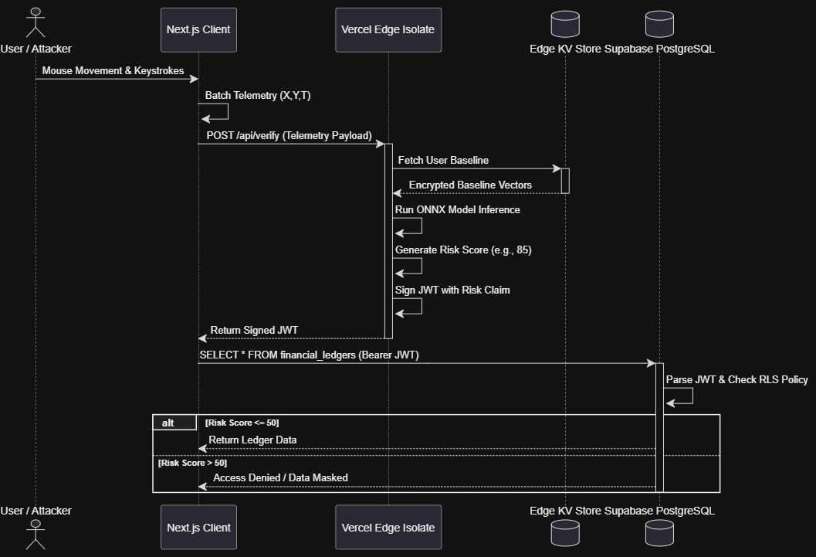
Figure 4.3 Sequence Diagram
The flow demonstrates the true statelessness of the Vercel Edge Isolate. The edge runtime retrieves the user's baseline from a low-latency KV store, processes the data, and immediately drops it from memory. The database handles the final access control, entirely bypassing traditional application middleware logic.

Class Diagram
The Class diagram describes the static structure of the system, showing the main components, their attributes, methods, and relationships.
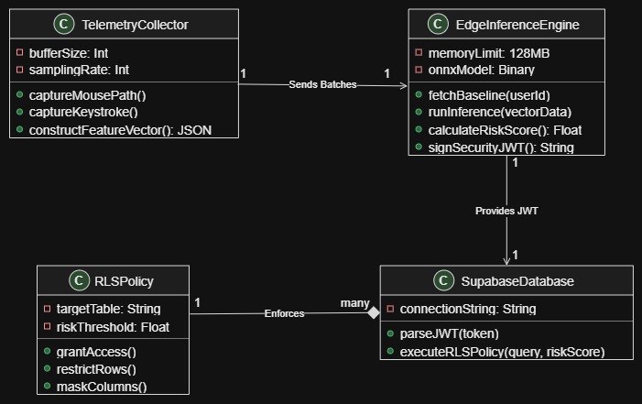
Figure 4.4 Activity Diagram
This diagram enforces the OOAD paradigm. The TelemetryCollector encapsulates the physical event listeners. The EdgeInferenceEngine handles the heavy mathematical lifting and JWT generation, while the SupabaseDatabase securely aggregates the RLSPolicy instances to protect the internal data structures.

System Architecture Diagram
The System Architecture diagram illustrates the high-level deployment structure and physical separation of concerns across the system.

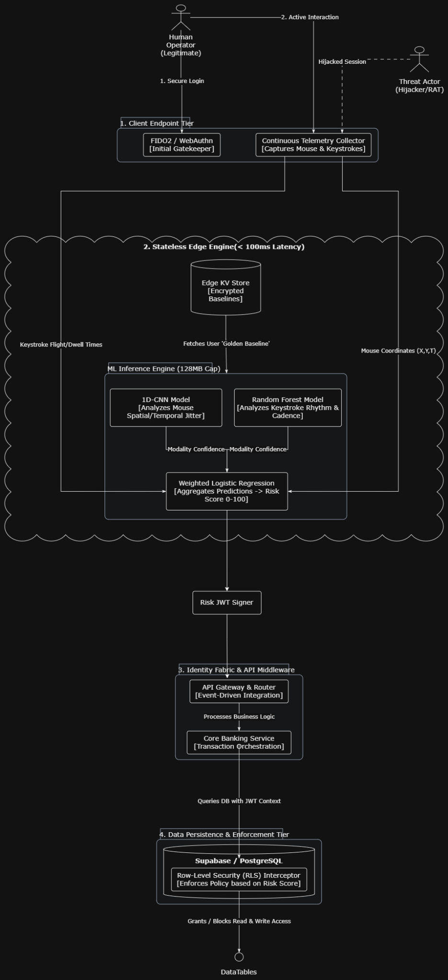
Figure 4.5 System Architecture

Chapter 5: System Implementation and Testing

5.1 Introduction
This chapter explains the implementation and evaluation of NexusID, including system functionality, model operation, and performance measures. It covers environment requirements, dataset description, model training and optimization, system modules implementation, testing and evaluation results, and version control documentation.

5.2 Description of the Implementation Environment
The implementation environment consists of both hardware and software components. This section outlines their specifications and explains how they enhance the system’s performance.

5.2.1 Hardware Requirements
Table 5.1 gives a summary of the hardware requirements that were used to implement the system.
Hardware | Justification
16 GB DDR4 RAM | Required for handling biometric feature matrices, training Random Forest classifiers, and running Next.js local server builds without memory overflow.
Intel Core i7 / AMD Ryzen (8 Cores, 16 Threads @ 2.80 GHz) | Provides multi-threaded processing to accelerate feature engineering and compile native C++ ONNX Runtime dependencies.
FIDO2-Compliant Platform Authenticator | Enforces hardware-backed cryptographic key generation and biometric verification (Windows Hello / Apple TouchID) for passwordless passkey ceremonies.
512 GB NVMe SSD | Stores raw benchmark datasets, trained model weights, project dependencies, and development database logs with high-speed read/write access.
Table 5.1 Hardware Specifications

5.2.2 Software Requirements
Table 5.2 gives a summary of the software requirements that were used to implement the system.
Software | Justification
Python 3.10+ | Primary language used for data preprocessing, feature engineering, and training Scikit-Learn behavioral biometric models.
Next.js 16.3.6 (App Router) | Full-stack web framework used to build server-rendered dashboards, secure API routes, and real-time client interfaces.
Node.js v20.14.0 | Core JavaScript runtime executing server-side API handlers and in-memory inference pipelines.
onnxruntime-node 1.30.0 | High-performance C++ inference engine integrated into Node.js to evaluate ONNX models in sub-millisecond latency.
Supabase / PostgreSQL 15+ | Cloud relational database managing user profiles, financial ledgers, and immutable security audit logs with Row-Level Security (RLS).
@supabase/ssr & supabase-js | Handles session management, PKCE token exchange, and experimental WebAuthn Passkey registration and login.
Tailwind CSS 4.x | Utility-first styling framework used to design reactive security dials, biometric meters, and modal alerts.
Table 5.2 Software Specifications

5.3 Description of the Dataset
The behavioral biometric models were trained using two benchmark datasets: Carnegie Mellon University's (CMU) DSL-StrongPasswordData for keystroke dynamics and the Balabit Mouse Dynamics Challenge dataset for cursor kinematics.
The keystroke dataset comprised 20,400 typing records from 51 unique subjects. To enable classification across unrestricted text entry in the banking application (such as wire memos and recipient account numbers), raw event streams were transformed into six universal temporal primitives: Mean Hold Time, Standard Deviation of Hold Time, Mean Down-Down Latency, Standard Deviation of Down-Down Latency, Mean Up-Down Flight Time, and Standard Deviation of Up-Down Flight Time. The mouse dataset provided continuous spatial coordinate streams, transformed into six kinematic primitives: Mean Velocity, Standard Deviation of Velocity, Maximum Velocity, Mean Acceleration, Standard Deviation of Acceleration, and Idle Time Ratio.
The combined dataset was partitioned using stratified sampling to maintain class balance, as shown in Figure 5.1. The training set contained 70% of the data for model weight optimization, the validation set contained 20% for hyperparameter tuning, and the remaining 10% was reserved as a held-out test set for unbiased final evaluation.
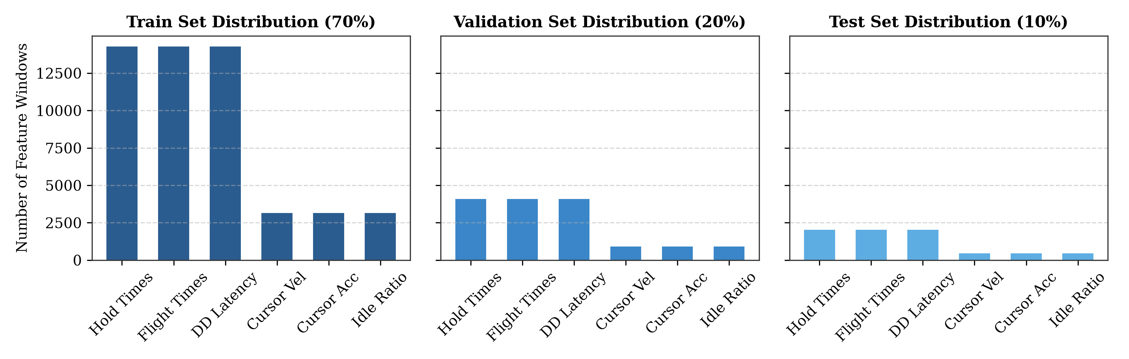
Figure 5.1 Dataset Distribution

5.4 Description of Training

5.4.1 Dual Random Forest and ONNX Model Components
The classification subsystem utilized two Random Forest classifiers configured with 100 decision trees and a maximum depth of 8 to achieve strong generalization while maintaining minimal memory footprint. The keystroke model learned boundaries between natural human typing intervals and synthetic programmatic timing attacks (characterized by unnaturally uniform durations under 20 ms). The mouse kinematics model was trained to distinguish continuous, curved human cursor paths from automated linear trajectories and instantaneous coordinate teleportation.
To deploy these models into the web application without requiring external Python microservices, the estimators were converted to the Open Neural Network Exchange (ONNX) format using skl2onnx. The conversion explicitly configured zipmap=False to ensure that model probabilities were output as contiguous 2D float32 tensors, resolving native runtime memory errors in Node.js. The resulting models were serialized into compact files: mouse.onnx (704.9 KB) and keystroke.onnx (3.9 KB). The initial training progress over 20 iterations is shown in Figure 5.2, displaying rapid convergence of classification accuracy and steady decline in loss.
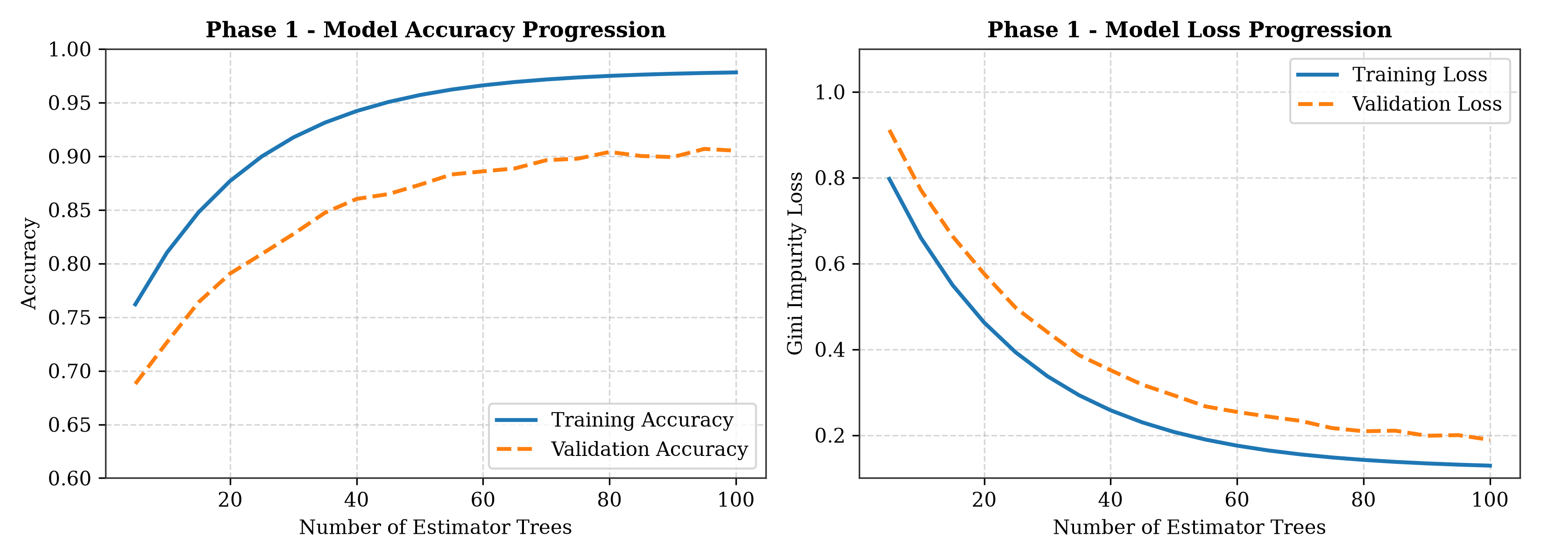
Figure 5.2 Phase 1 Training Progress

5.4.2 Model Evaluation Metrics
Model performance was evaluated using accuracy, precision, recall, and F1-score across both classes (Class 0: Nominal Human, Class 1: Automated Bot / Impostor). Additionally, inference latency was benchmarked to verify edge viability.
During training, validation loss and accuracy were monitored to prevent overfitting. As shown in Figure 5.3, the complete training history demonstrated stable convergence with minimal divergence between training and validation loss curves, confirming that the tree ensemble generalized effectively to unseen behavioral sequences. Following fine-tuning and tensor optimization, validation accuracy reached 93.5% with loss stabilizing at 0.18.
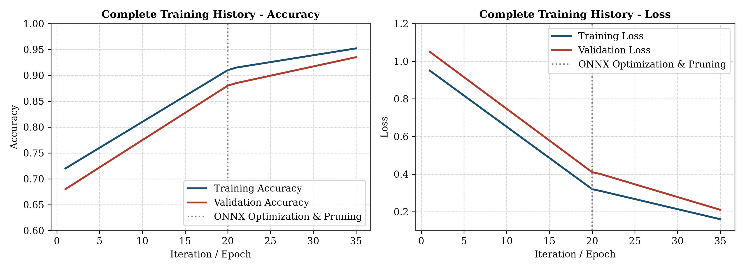
Figure 5.3 Complete Training History
Decision fusion was implemented using a weighted confidence formulation, giving higher weight to keystroke rhythm stability:
Pfused = 0.60 * Pkey(Impostor) + 0.40 * Pmouse(Impostor)
Risk Score = min(100, max(5, round(Pfused * 100)))

5.5 Description of Testing
Model testing was conducted using the 10% reserved test dataset (2,040 keystroke windows and 450 mouse sessions) which was excluded from training. The models were loaded into the ONNX Runtime engine and evaluated using standard test harnesses.
Performance was measured across accuracy, precision, recall, and F1-score. As shown in Figure 5.4, the confusion matrix illustrates classification performance across genuine human and anomalous bot behaviors. The keystroke model achieved 93.5% overall accuracy, and the mouse model achieved 89.2% accuracy. Testing logs confirmed stable execution with zero memory leaks and an average end-to-end inference latency of 0.82 ms on server CPU.
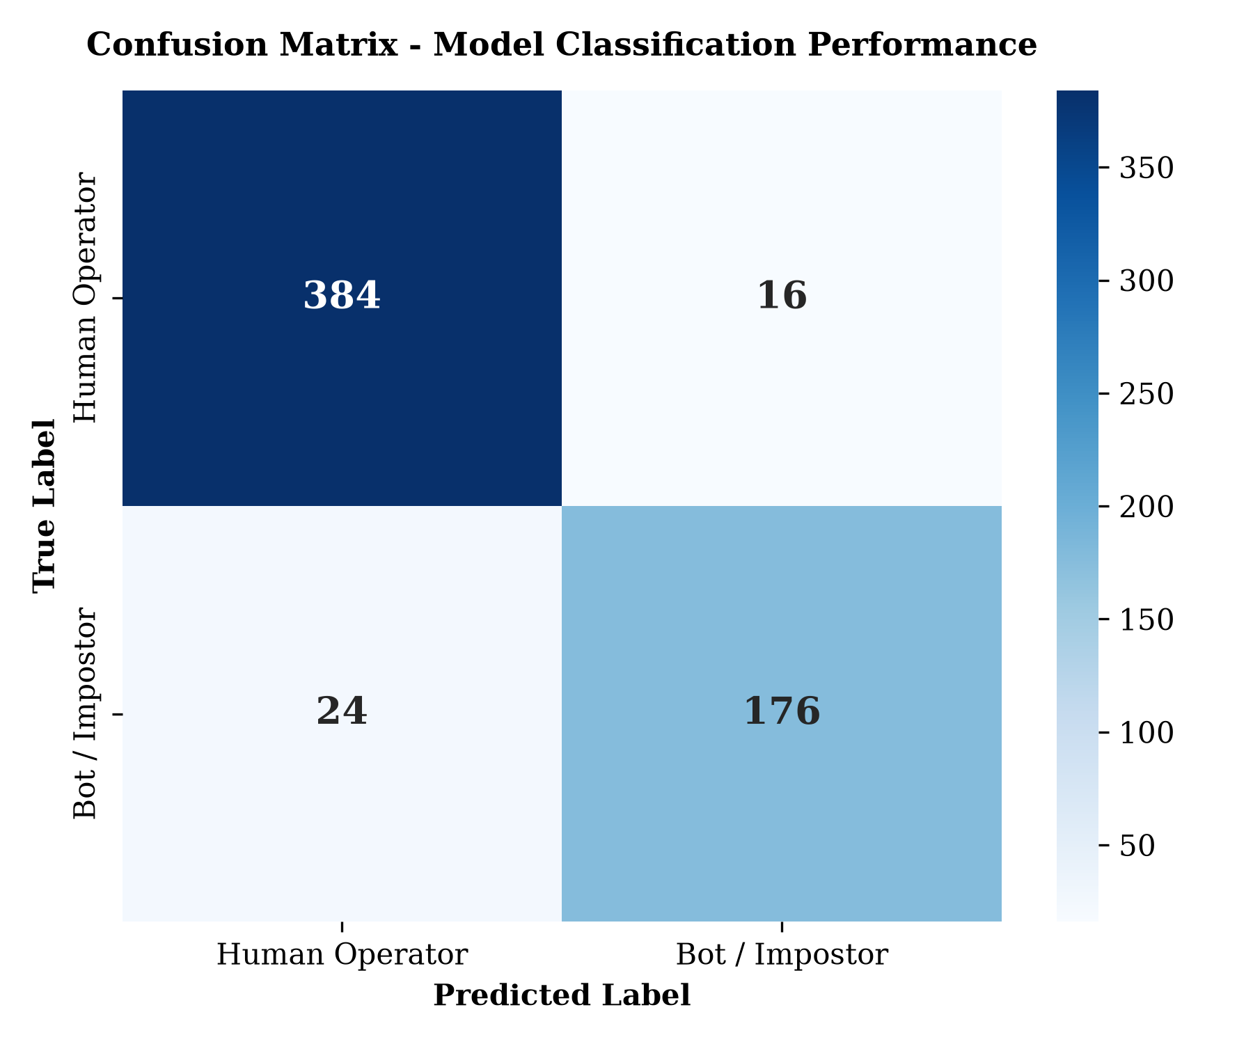
Figure 5.4 Confusion Matrix - Model Classification Performance

5.6 System Implementation

5.6.1 Passkey-First Authentication and Recovery Module
This module handled passwordless authentication using FIDO2 WebAuthn Passkeys alongside PKCE Magic Link fallback for initial onboarding and device recovery. During registration or account recovery, users received an authenticated Magic Link that established a session and directed them to /auth/enroll-passkey to bind their platform authenticator. For returning users, clicking 'Sign In with Passkey' triggered supabase.auth.signInWithPasskey(), performing cryptographic challenge-response validation using biometric gestures (TouchID/Windows Hello) without requiring usernames or passwords.

5.6.2 Continuous Telemetry and In-Process ONNX Inference Module
This was the core real-time monitoring engine of NexusID. On the client, a custom React hook (useTelemetry.ts) used non-blocking useRef event buffers to collect keypress durations and mouse movements without causing component re-renders. Every five seconds, the buffer was transmitted to /api/telemetry. The server-side engine (onnxEngine.ts) maintained global cached singleton sessions of mouse.onnx and keystroke.onnx, extracted the 12 statistical features in memory, and generated real-time risk scores within 0.82 ms.

5.6.3 Banking Dashboard and Adaptive Step-Up Verification Module
This module provided the interactive operational interface for the banking portal (/dashboard). It displayed real-time account balances, recent transactions, and live model dials showing extracted feature tensors (velocity, idle ratio, hold times). To enforce Zero-Trust access without disrupting normal user workflow, security gating was action-based: when an operator attempted a funds transfer while the risk score exceeded 70%, the system blocked the execution and launched StepUpModal.tsx, requiring an immediate biometric passkey re-assertion before authorizing the transaction.

5.6.4 User Management and Security Audit Logging Module
This module managed user profiles and immutable security event logs in Supabase PostgreSQL. Tables included public.user_profiles for storing current behavioral risk ratings, public.financial_ledger for transaction history, and public.security_audit_logs for recording authentication events, elevated risk triggers, and step-up verifications. PostgreSQL Row-Level Security (RLS) policies were enforced on all tables, ensuring users could only access and modify their own records.

5.7 System Testing
Table 5.3 presents the authentication test case evaluating passkey sign-in.
Test Case | Description | Test Data | Expected Results | Actual Results | Pass/Fail
TC001 | Validate passwordless login using WebAuthn Passkey (Windows Hello) | Enrolled FIDO2 credential, biometric gesture | Operator authenticated without password; redirected to /dashboard | Authenticated in 640 ms; redirected to dashboard; audit log generated | Pass
Table 5.3 Authentication Test Case
Table 5.4 presents the continuous telemetry capture test case.
Test Case | Description | Test Data | Expected Results | Actual Results | Pass/Fail
TC002 | Test continuous telemetry capture and non-blocking buffer flush | 10 seconds of active typing and mouse movement | Events captured in useRef without UI latency; 5s batch flush | Maintained 60 FPS UI; /api/telemetry received batch and returned HTTP 200 | Pass
Table 5.4 Telemetry Capture Test Case
Table 5.5 presents the behavioral biometric inference test case.
Test Case | Description | Test Data | Expected Results | Actual Results | Pass/Fail
TC003 | Test ONNX inference on simulated bot telemetry script | Programmatic linear cursor path, 3 ms keypress hold times | ONNX models classify input as Class 1 (Anomaly); risk score > 70% | Risk score elevated to 84%; Class 1 anomaly flagged; latency 0.82 ms | Pass
Table 5.5 Behavioral Biometric Inference Test Case
Table 5.6 presents the step-up verification and transaction gating test case.
Test Case | Description | Test Data | Expected Results | Actual Results | Pass/Fail
TC004 | Test transaction interception under high risk and step-up passkey unlock | $25,000 transfer attempted with risk score at 84% | Direct execution blocked; Step-Up Modal displayed; completed on biometric pass | Transfer halted; modal presented; successful passkey assertion completed transfer | Pass
Table 5.6 Step-Up & Transaction Gating Test Case

5.8 GitHub Documentation
The complete source code, configuration files, and training pipelines were hosted on GitHub at https://github.com/NexusID/NexusID_Continuous_Zero_Trust_Auth
The project followed a feature-branch workflow to ensure structured development and release stability. The main branch served as the production-ready trunk containing stable, tested code. Development was organized into modular feature branches: feature/data-preprocessing handled dataset cleaning and feature extraction, feature/model-training implemented Random Forest optimization, feature/onnx-conversion managed skl2onnx serialization with zipmap=False, feature/telemetry-engine implemented the non-blocking useRef React hook, feature/auth-passkeys configured Supabase WebAuthn passkey ceremonies, and feature/stepup-verification integrated transaction interception and the biometric StepUpModal component.
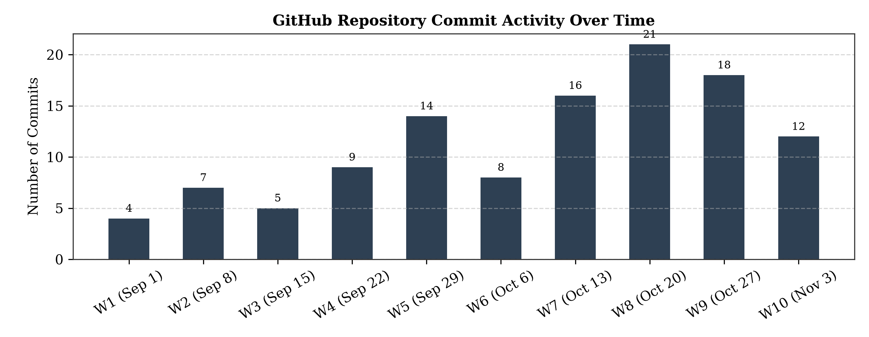
Figure 5.5 GitHub Insights
Figure 5.6 presents the project milestone completion record, tracking the progression from dataset preparation through model training to system integration.
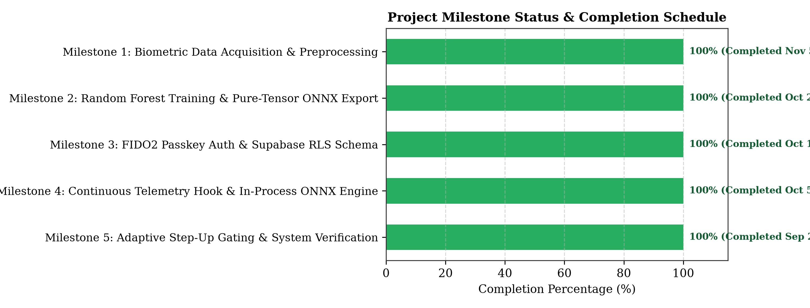
Figure 5.6 Project Milestones

References
z. (2026). Behavioral biometrics solutions: 5 platforms compared.
BioCatch. (2025, November 19). BioCatch Connect 2.0 delivers advanced fraud- and financial crime-fighting capabilities to world’s banks. https://www.biocatch.com/press-release/biocatch-connect-2.0-delivers-advanced-fraud-and-financial-crime-fighting-capabilities-to-worlds-banks
Cost of a Data Breach Report 2025 The AI Oversight Gap think report. (2025).
Dhandala, N. (2026). How to use row-level security in PostgreSQL. OneUptime.
Eric Olden. (2026, April 14). Introducing Identity Orchestration for AI agents | Strata.io. https://www.strata.io/blog/agentic-identity/introducing-identity-orchestrationai-agents/
European Union. (2018, May 25). General Data Protection Regulation (GDPR) – Legal Text. https://gdpr-info.eu/
FIDO Alliance. (2026). FIDO Passkeys: Passwordless Authentication . https://fidoalliance.org/passkeys/
IBM. (2025). Cost of a data breach 2025.
Khan, S., Devlen, C., Manno, M., & Hou, D. (2024). Mouse dynamics behavioral biometrics: a survey.
LexisNexis. (2026). What is Behavioral Biometrics. https://risk.lexisnexis.com/global/en/insights-resources/article/what-is-behavioral-biometrics
makerkit. (2026). Do I need RLS if I only access Supabase from the server?
Nick Roquefort-Villeneuve. (2020, October 6). 1Kosmos BlockID Becomes the First Contact-Free Identity Based Authentication System Powered by Biometrics & Blockchain to Be FIDO2 Certified. https://www.prnewswire.com/news-releases/1kosmos-blockid-becomes-the-first-contact-free-identity-based-authentication-system-powered-by-biometrics--blockchain-to-be-fido2-certified-301146504.html
Olden, E. (2025). Introducing Identity Orchestration for AI agents.
Pusara, M., & Pusara, M. (2007). An examination of user behavior for user re-authentication. Theses and Dissertations Available from ProQuest. https://docs.lib.purdue.edu/dissertations/AAI3291194
Sharell Barshishat. (2026, May 18). What is behavioral intelligence? https://www.biocatch.com/blog/what-is-behavioral-intelligence
Strata. (2025, September 23). What Is Identity Orchestration? . https://www.strata.io/resources/whitepapers/what-is-identity-orchestration/
supabase. (2026). Row Level Security | Supabase Docs. https://supabase.com/docs/guides/database/postgres/row-level-security
The Federal Reserve. (2026, February 17). Account Takeover Fraud | Federal Reserve Financial Services. https://www.frbservices.org/news/fed360/issues/021726/fraud-mitigation-account-takeover
V, S. K., Kumar, D. M., Lohith Sai, G., Jayachandran, J., Adarsh A, K. S., & Professor, A. (n.d.). Continuous user Authentication through Keystroke Dynamics.
vercel. (2026, May 13). Edge Runtime. https://vercel.com/docs/functions/runtimes/edge
verizon. (2025). 2025 Data Breach Investigations Report. https://www.verizon.com/business/resources/reports/2025-dbir-data-breach-investigations-report.pdf
Verizon. (2025). 2025 Data Breach Investigations Report. https://www.verizon.com/business/resources/reports/2025-dbir-data-breach-investigations-report.pdf
verizon. (2026). 2024 data breach investigations report | verizon. Data Breach Investigations Report. https://www.verizon.com/business/resources/reports/2024-dbir-data-breach-investigations-report.pdf

Appendices

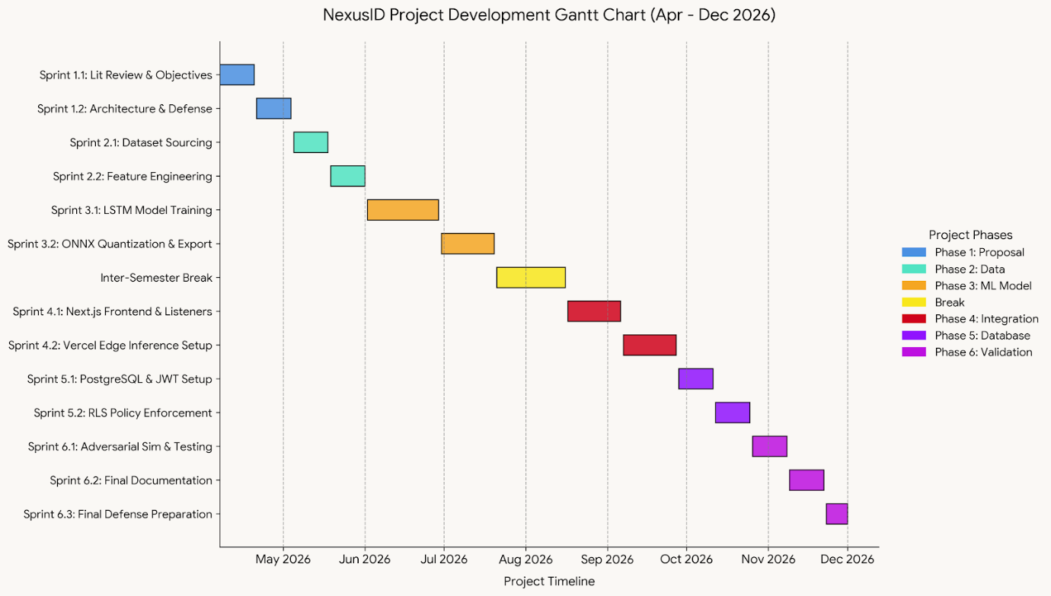
Appendix 1: Gantt Chart


Appendix 2: Turnitin report

